BDA400 Assignment 2 Report — Technical Analysis using R

Student - Stephenie Olorunmaiye
Course: - BDA400 — Data Science Tools and Techniques
Repository required: - `TechnicalAnalysis`
Repository URL: https://github.com/stephenieolorunmaiye/TechnicalAnalysis

1. GitHub account and repository
The assignment requires a repository named `TechnicalAnalysis` to store course assignments.

**Screenshot 1 — Repository

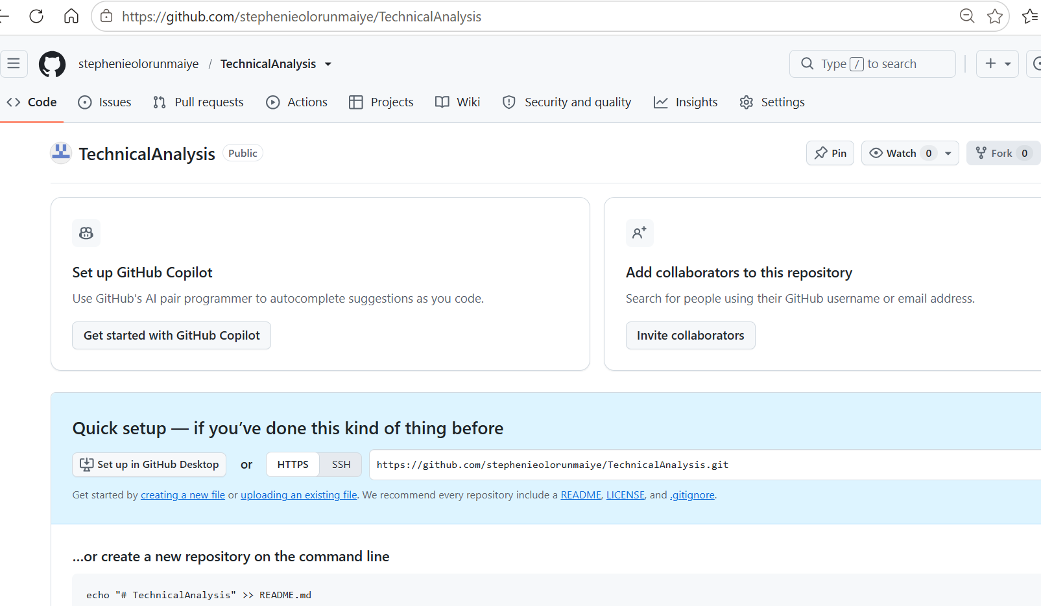
https://github.com/stephenieolorunmaiye/TechnicalAnalysis
## 2. R and RStudio installation
My earlier RStudio screenshot displayed R version 3.6.1 (2019-07-05). This is an older version. Record the version you actually use for this assignment.

**Screenshot 2 — R version: 4.6.1
**Screenshot 3 — RStudio:
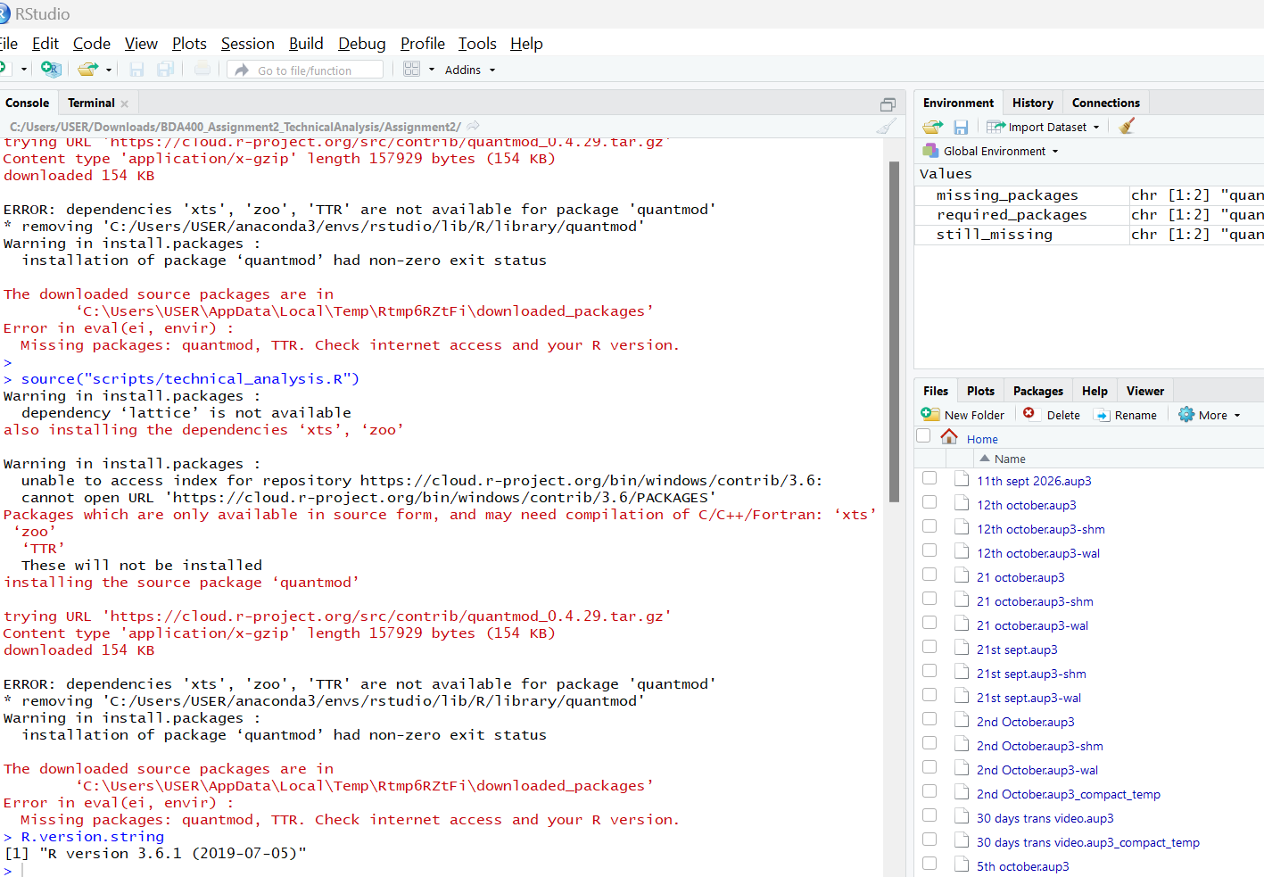

## 3. Package installation
The script uses `quantmod` to retrieve stock data and `TTR` to calculate a simple moving average.

```r
install.packages(c("quantmod", "TTR"))
packageVersion("quantmod")
packageVersion("TTR")
```

**Screenshot 4 — Package installation/version:** [Insert genuine screenshot or document the exact error.]
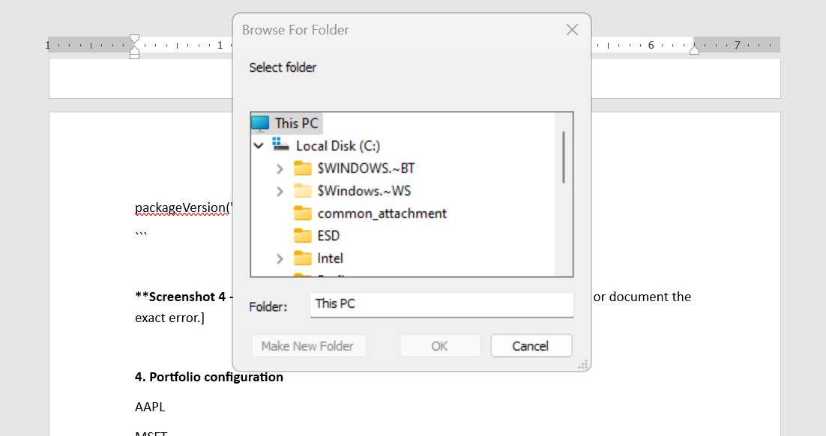

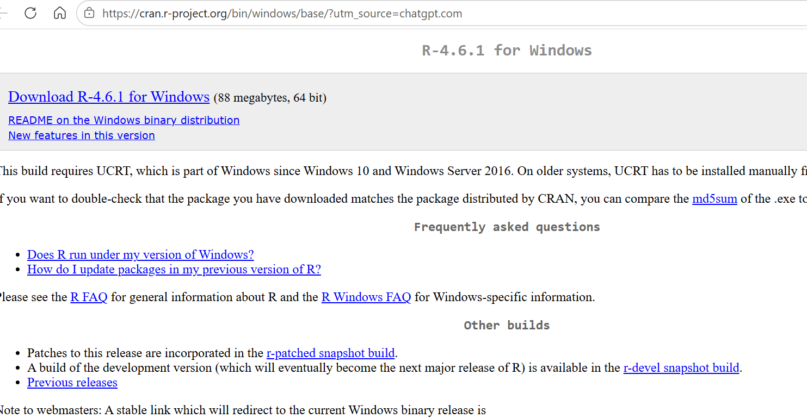
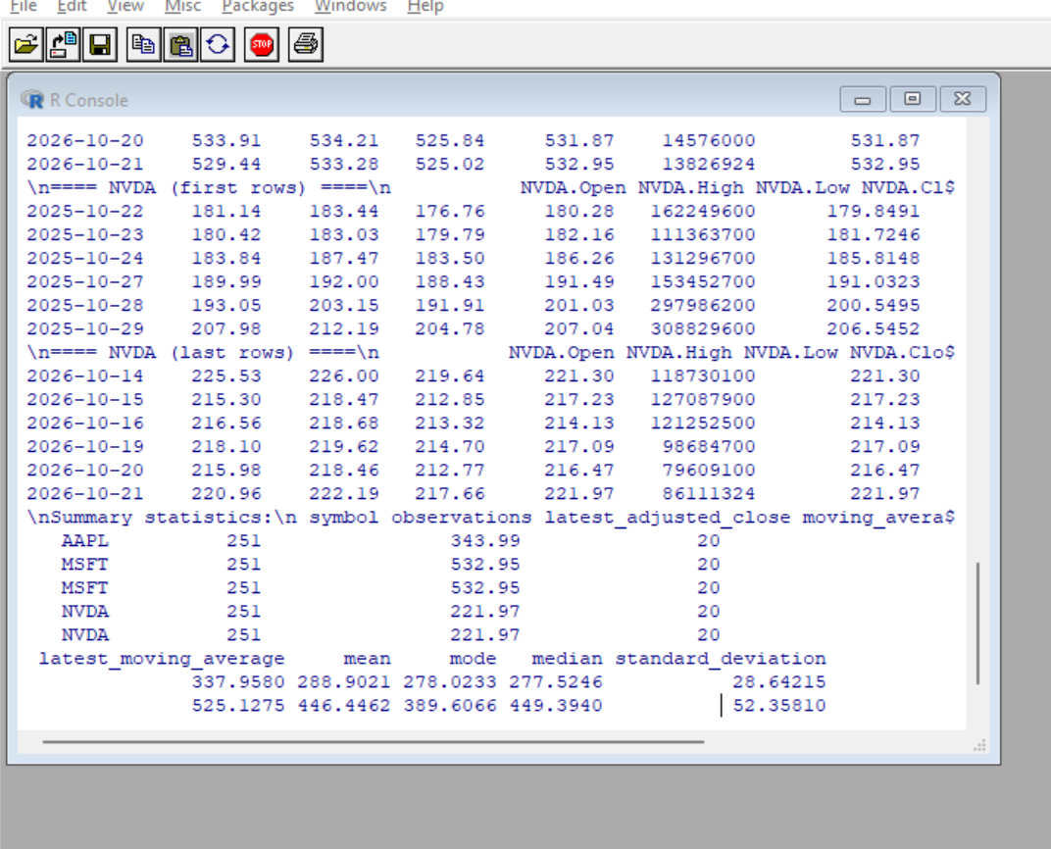
4. Portfolio configuration
AAPL
MSFT
NVDA
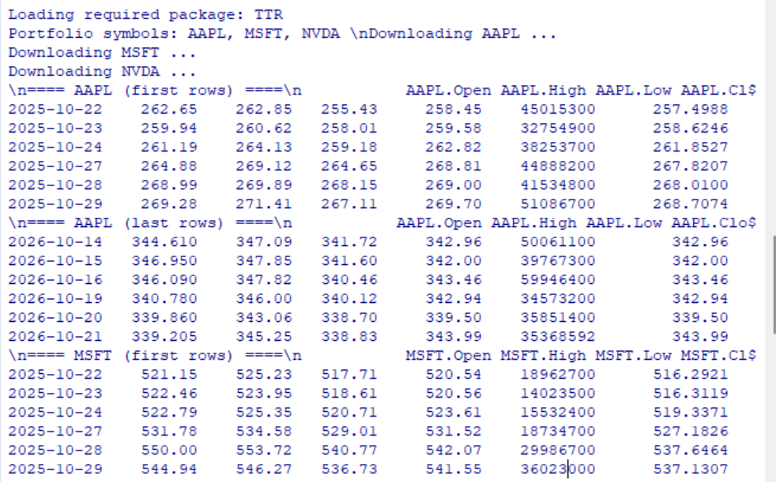
**Screenshot 5 — portfolio.txt

## 5. Importing stock data
`read_portfolio()` reads the symbols. `load_stock_data()` downloads historical data from Yahoo Finance through `quantmod` and stores successful downloads in a named list.
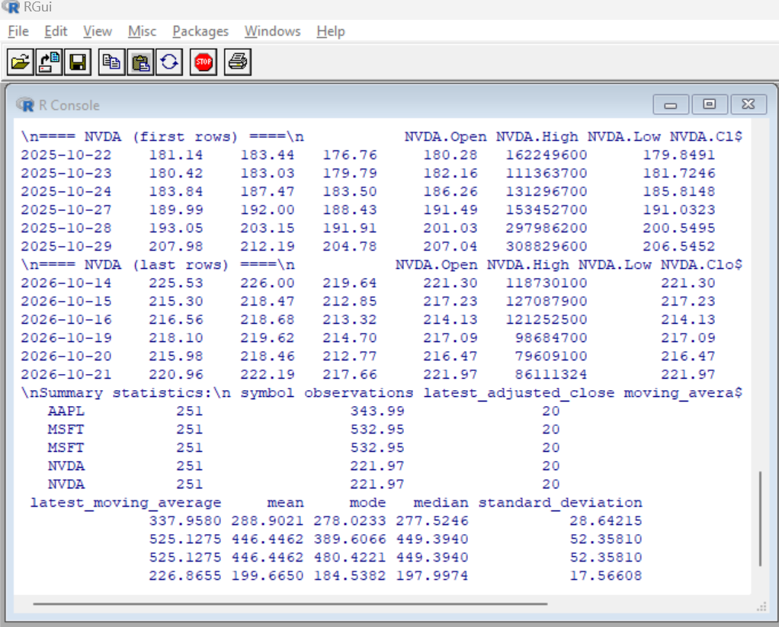
**Screenshot 6 — Code and actual import output:**
Note any failed downloads; internet access and provider availability can affect results.
## 6. Calculating statistics
`calculate_statistics()` uses adjusted closing prices to calculate observation count, latest adjusted close, latest 20-day simple moving average, mean, mode, median, and standard deviation. If no value repeats, the mode is reported as `NA`.

**Screenshot 7 — Actual summary table:** [Insert screenshot.]

## 7. Display and visualizations
The script prints the first and last six rows for each downloaded ticker. It saves `outputs/stock_statistics.csv`, one data CSV per ticker, and a PNG chart showing adjusted close and the 20-day SMA.

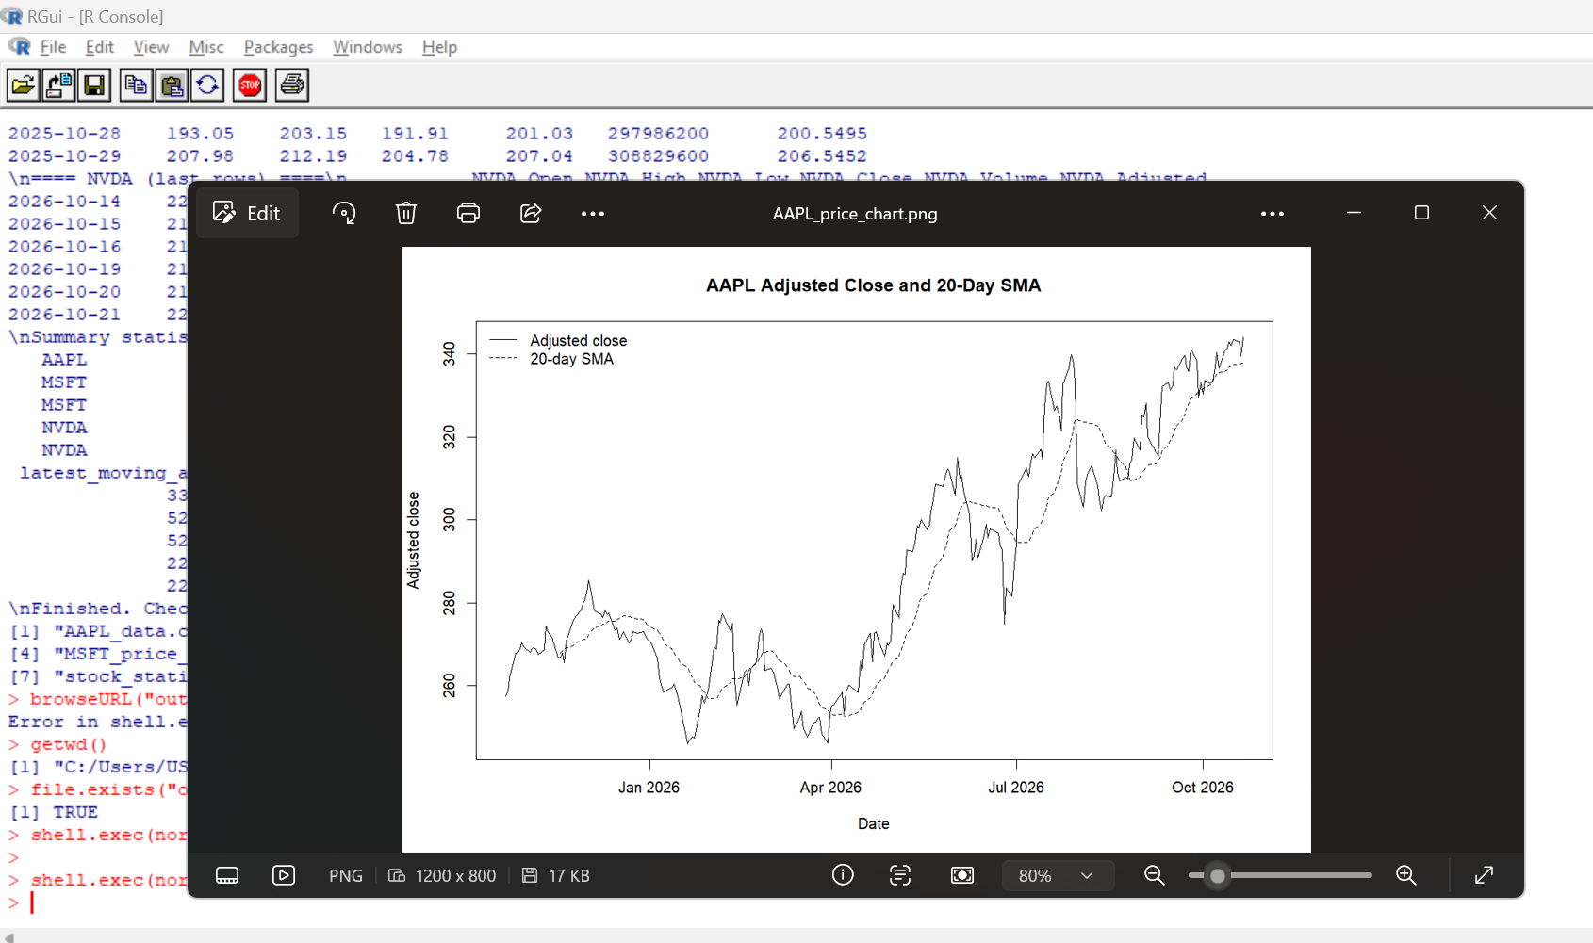

**Screenshot 8 —
**Screenshot 9 — Price chart
8. Running the script
Set the working directory to this `Assignment2` folder (the folder containing `portfolio.txt`), then run:
9. Verification record
- R version used: [fill in]
- `quantmod` installed/version: [fill in]
- `TTR` installed/version: [fill in]
- Symbols successfully downloaded: [fill in]
- CSV outputs created and inspected: [yes/no and details]
- Charts created and inspected: [yes/no and details]
- Independent spot-check of a statistic: [explain your check]
- Errors and fixes: [fill in]

10. Conclusion
The assignment demonstrated how R can be used to analyse historical stock prices for Apple (AAPL), Microsoft (MSFT), and NVIDIA (NVDA). During testing, the script displayed stock data and calculated summary statistics, including the latest adjusted closing price, 20-day simple moving average, mean, mode, median, and standard deviation. The output folder also contained four CSV files and three PNG chart files.
I learned how to organise a stock portfolio using a text file, run an R script from the correct working directory, calculate descriptive statistics, and save analysis results for further examination. I also learned the importance of checking package dependencies, reviewing Console messages, and verifying that output files are generated correctly.
One limitation encountered was the initial failure to install the required packages because some dependencies were unavailable through the configured repository for my R 3.6.1 environment. Although analysis results and output files were subsequently displayed, the package versions, CSV contents, and chart contents still require final verification. The analysis also depends on internet access and the availability of historical stock data from Yahoo Finance.
Overall, the assignment provided practical experience in data analysis and troubleshooting in R. The results describe historical price behaviour and should not be treated as predictions of future stock performance or financial advice.

AI assistance disclosure
ChatGPT (GPT-6), accessed 21 October 2026, assisted with organizing this report draft and suggesting code structure. I must review the code, run it in my own R environment, capture genuine screenshots, and document actual verification. The tool did not verify my local installation, package installation, live downloads, or outputs.

